12.51: Solving Eq. (12.14) for r,
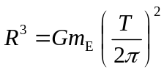
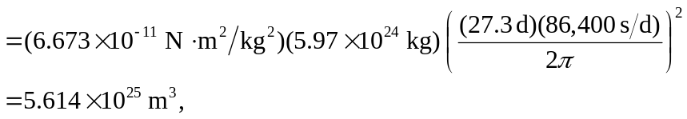
from which 